OSCN LAB – 3
Name: SANIYA TAHSEEN Date: 21/10/2025

Task:1
Problem-01: A bit stream 1101011011 is transmitted using the standard CRC method. The generator polynomial is x⁴+x+1. What is the actual bit string transmitted?
Ans: Given:
- Data bits: 1101011011
- Generator polynomial: x⁴ + x + 1 → generator bits: 10011 Code:
#include <iostream> #include <string> using namespace std;

// Function to perform XOR operation between two binary strings string xorOperation(string a, string b) { string result = "";
for (size_t i = 1; i < b.size(); i++) result += (a[i] == b[i]) ? '0' : '1'; return result;
}

// Function to perform modulo-2 division string mod2Division(string dividend, string divisor) { int pick = divisor.size();
string tmp = dividend.substr(0, pick); int n = dividend.size();

while (pick < n) { if (tmp[0] == '1')
tmp = xorOperation(divisor, tmp) + dividend[pick]; else
tmp = xorOperation(string(pick, '0'), tmp) + dividend[pick]; pick++;
}

// For the last n bits if (tmp[0] == '1')
tmp = xorOperation(divisor, tmp); else
tmp = xorOperation(string(pick, '0'), tmp);

return tmp;
}

int main() {
string data = "1101011011"; string generator = "10011";

int m = generator.size();
string appendedData = data + string(m - 1, '0'); // Append (m-1) zeros

cout << "Data bits: " << data << endl; cout << "Generator: " << generator << endl; cout << "Appended data: " << appendedData << endl;

string remainder = mod2Division(appendedData, generator); cout << "Remainder (CRC bits): " << remainder << endl;

// XOR remainder with appended data to get transmitted codeword string transmitted = data + remainder;
cout << "Transmitted frame (data + CRC): " << transmitted << endl;

return 0;
}
Output:
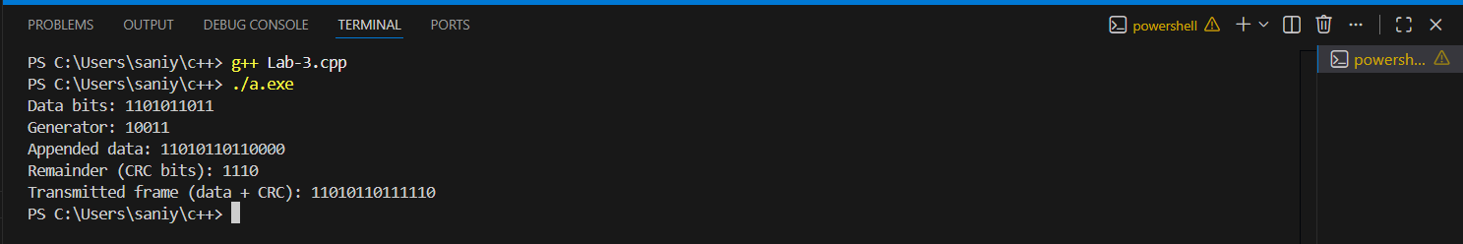
Explanation
- Data bits = 1101011011
- Generator polynomial = x⁴ + x + 1 → Generator bits = 10011
- Append 4 zeros (degree of generator = 4) to data → 11010110110000
- Perform mod-2 division (XOR based) → remainder = 1110
- Actual transmitted frame = 1101011011 + 1110 = 11010110111110
Therefore, the actual bit string transmitted is: 11010110111110

Task:2
Problem-02:
A bit stream 10011101 is transmitted using the standard CRC method. The generator polynomial is x³+1
1.What is the actual bit string transmitted?
2. Suppose the third bit from the left is inverted during transmission. How will receiver detect this error?
Code:
#include <iostream> #include <string> using namespace std;

// XOR operation between two binary strings (skip the first bit) string xorOp(string a, string b) { string result = ""; for (int i = 1; i < b.size(); i++) { if (a[i] == b[i]) result += '0'; else result += '1';
}
return result;
}

// Perform Modulo-2 Division string mod2Division(string dividend, string divisor) { int pick = divisor.size(); string tmp = dividend.substr(0, pick); int n = dividend.size();

while (pick < n) { if (tmp[0] == '1') tmp = xorOp(divisor, tmp) + dividend[pick];
else
tmp = xorOp(string(pick, '0'), tmp) + dividend[pick]; pick++;
}

if (tmp[0] == '1') tmp = xorOp(divisor, tmp);
else tmp = xorOp(string(pick, '0'), tmp);

return tmp;
}

// Flip (invert) a bit at a given position string flipBit(string s, int pos) { if (pos < 0 || pos >= s.size()) return s; if (s[pos] == '0') s[pos] = '1'; else s[pos] = '0'; return s;
}

int main() { string data = "10011101"; // Given data bits string generator = "1001"; // Given generator polynomial (x^3 + 1) int genDegree = generator.size() - 1;

cout << "Data bits: " << data << endl; cout << "Generator bits: " << generator << endl;

// Step 1: Append (m-1) zeros string appended = data + string(genDegree, '0'); cout << "Appended data: " << appended << endl;

// Step 2: Perform division to find remainder (CRC) string remainder = mod2Division(appended, generator); cout << "Calculated CRC (remainder): " << remainder << endl;

// Step 3: Form transmitted frame string transmitted = data + remainder; cout << "Transmitted frame (data + CRC): " << transmitted << endl;

// Step 4: Simulate bit error (flip 3rd bit from left) int flipIndex = 2; // 0-based index string received = flipBit(transmitted, flipIndex); cout << "\nSimulate error: flip 3rd bit from left" << endl; cout << "Received frame: " << received << endl;

// Step 5: Receiver checks CRC again string recvRemainder = mod2Division(received, generator); cout << "Receiver remainder: " << recvRemainder << endl;

// Step 6: Check if remainder is all zeros bool isZero = true; for (int i = 0; i < recvRemainder.size(); i++) { if (recvRemainder[i] != '0') { isZero = false;
break;
}
}

if (isZero) cout << "Receiver: No error detected (remainder is zero)." << endl;
else
cout << "Receiver: Error detected (non-zero remainder)." << endl;

return 0;
}
Output:
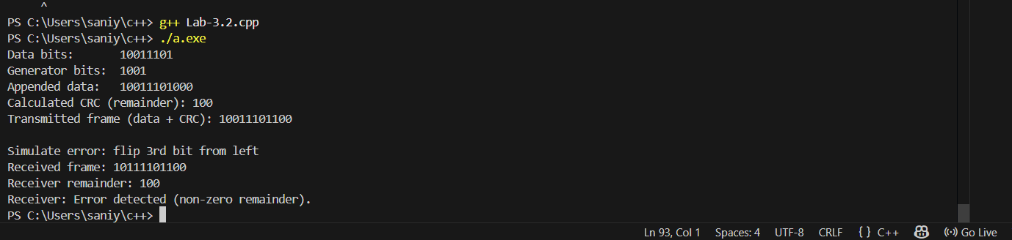
- Actual transmitted bit string: 10011101100
- After 3rd bit inversion, receiver remainder = 100 → Error detected

